GUIDELINE FOR
Incoming Exchange Students

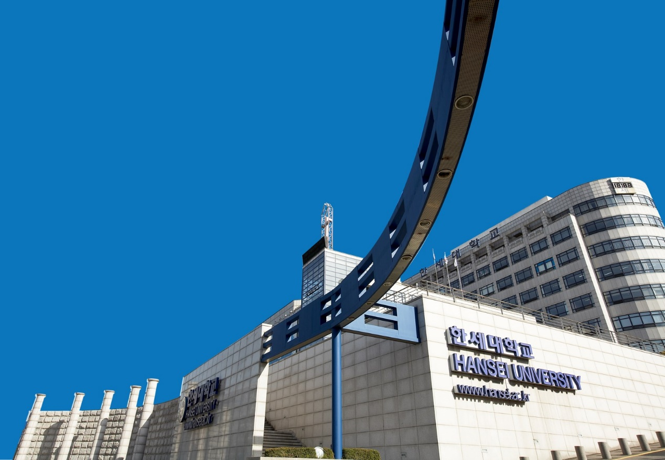

HANSEI UNIVERSITY
AUTUMN 2021，SPRING 2022
As Global Citizens, Take Your First Step at HANSEI
国际化领导人的第一步，
韩世大学陪你一起走
글로벌 리더의 첫발, 한세대학교
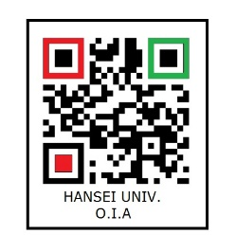
Application Processes for
Inbound Exchange Students
邀请交换生招生日程表
- Autumn 2022 (Class opens in Sep, 2022 / Closes in Dec, 2022)
2022年 秋季班(开学日期 2022年9月 / 结束日期 2022年12月)
Events (事项) | Date (日期)
Application Submission (报名) | Early April – Mid-May, 2022
Application Deadline (报名截止日) | May 28, 2022
Notification of Acceptance (录取通知) | June 1, 2022
Enrollment (入学注册) | Mid-August, 2022

- Spring 2022 (Class opens in March, 2022/ Closes in June, 2022)
2022年 春季班(开学日期 2022年3月 / 结束日期 2022年6月)
Events (事项) | Date (日期)
Application Submission (报名) | Early October – Mid-Nov. 2021
Application Deadline (报名截止日) | November 15, 2021
Notification of Acceptance (录取通知) | November 29, 2021
Enrollment (入学注册) | Mid-February, 2022

The above schedule can be changed based on the school status
★以上的日程由本校的状况会有些变动

How to Apply?
报名方式

Step1：
- Homepage: http://hsiec.hansei.ac.kr
Please scan all of the required documents for exchange students & email them to: iec.hansei@gmail.com
Title: Exchange Student “Name of College or University”
We’ll reply you when we receive your application email.
- 参考首页: http://hsiec.hansei.ac.kr
请把所有申请文件必须扫描后，寄至: iec.hansei@gmail.com

Step2：
All of the required documents for exchange students or other supporting documents shall be sent by postal mail to the following address:
Hansei University
Office of International Affairs
Address: # 703, Graduate Building, 30, Hansei-ro,
Gunpo-city, Gyeonggi-do, 15852, Republic of Korea
Tel: +82-31-450-5140, +82-31-450-5216
所有申请文件或其他证明文件邮寄到以下的地址:
韓世大學 國際交流教育院
地址：15852 京畿道軍浦市韓世路30大學院館7樓
電話：+82-31-450-5140, +82-31-450-5216

Guideline for Inbound Exchange Students
介绍邀请交换生课程
1. Tuition(学费):
- The tuition fee for exchange students is charged or waived based on the agreement.
- Exchange students can study the Korean language courses & their tuition fee for those courses is charged or waived based on the agreement. (Without cultural experience fee, it is KRW 50,000)
- Based on the agreement, tuition waivers for Korean language courses are only available during spring & fall quarters, not during summer & winter quarters.
- 交换生的学费依据协定书支付或者豁免.
- 交换生可参加韩语课程，该课程的学费依据协定书支付或者豁免. (不含文化体验费, KRW 50,000)
- 依据协定书,语学堂免学费只限于春季班和秋季班，夏季班和冬季班必须缴纳学费.
2. Curriculums(课程):
- Exchange students can study Korean language course & degree curriculum depending on their Korean language ability.
- Most degree courses are taught in Korean & some conversational subjects taught in Chinese & English.
- Exchange students with Korean ability less than TOPIK 4 must study the Korean language course(www.hskli.com)
- The enrollment for curriculum for exchange students usually starts one week before the opening of each semester.
- However, the application for course enrollment can be closed on the first served basis.
- Hansei University can decline the students’ course registration requests based on its curriculum regulations.
- Korean language course - Class time: 09: 00 ~ 13: 00 (Monday to Friday).
A total of 200 hours in 10 weeks(For one quarter).
- Korean language course is offered by Hansei University; 5 courses in total.
(Speaking, Listening, Reading, Writing, Attitude)
9) Course credit recognition is the responsibility of the students’ home university.
1) 交换生根据自己的韩语水平，可以同时学习语学堂和学位课程.
2) 大部分学位课程用韩语讲课，一些课会用中文与英语讲课.
3) 但学生韩语能力不到TOPIK 4级，必须要上语学堂的课程. (www.hskli.com)
4) 交换生的选课一般在每学期开学一周前进行.
5) 选课是按照选后顺序有可能选课早点结束.
6) 韩世大学依据课程规定，有权拒绝交换学生的选课要求.
7) 韩国语学堂上课时间 : 周一到周五/每日4个小时(上午9点~下午1点)
一学期一共200个小时 10周（1个学期）
8) 韩世大学韩国语学堂的课程：总共4项（会话，听力，阅读，写作文）
9) 学分认可由学生所属学校负责.

3. about Dormitory (学校宿舍)
1) Dormitory fee: KRW 700,000 / 1 semester (2-persons per room)
2) In-school & dormitory area, free wireless internet service is available.
3) Single Bed & desk furnishings provided in the dorm room
(However, bed covers, pillow & blankets are not provided)
1) 宿舍费 : 韩币700,000元 /1学期, 2人一间房
2) 学校内及宿舍内可免费使用无线网.
3) 宿舍内提供床和桌椅（但床罩，枕头，被子等个人购买）

4. about Pick up Service (Airport to Hansei Univ.)
有关接机服务(从机场到韩世大学）
- Pick-up service is available free of charge only for the first time by condition base
- Condition: Students arriving at Incheon International Airport from 10:00 am to 3:00 pm on the specified date
- For information about how to move personally from the airport to the school, visit the website(http://hsiec.hansei.ac.kr)
1) 接机服务在满足条件的情况下第一次可免费提供.
2) 条件：
在指定日期，从上午10点到下午3点到达仁川国际机场的学生.
3) 从机场到学校个人移动的方法请参考网页(http://hsiec.hansei.ac.kr).

5. Additional cost (附加费用)
- Foreigners Insurance: KRW 40,000 per month
- Application for Alien Registration Card: KRW 30,000
- Korean cultural experience fee, KRW 50,000(Not in service until the termination of COVID-19)
- 外籍学生保险费：每个月 韩币40,000
- 申请外国人登陆证手续费：韩币 30,000
- 韩国文化体验费：韩币50,000（文化体验活动到COVID-19疫情变好为止暂时中断）

Application & Related Documents
(Exchange Student Program for Hansei University)
申请及相关文件

1. Application forms, 申请书 (Form No.1~ No.3)
2. Copy of Passport, 护照复印件
3. Three ID Pictures (3.5cm X 4.5cm, Color photo of face, front view, on white background taken within the past six months)
照片(3.5cm X 4.5cm, 白底2寸照片) 3张
4. A JPG file of the ID picture
5. Scanned of Bank Statement (over USD 4,500.00 for one semester / over USD 9,000.00 for two semesters)
(This financial Bank Statement should be prepared before your visa interview.)
存款证明书（存一个月以上，最低4,500~9,000美元）
6. Family Certificate 亲属关系证明(外交部认证)
(Only when the bank account holder is one of students’ parents.)
7. Reference Letter by Home University (free format)
学校的推荐信
8. Proof of Enrollment of Home University
学生在校证明书

* Above documents are subject to change.
★以上的内容由本校的状况会有些变动

Multiplex activities of Inbound exchange students
邀请交换学生的多种活动

Airport pick-up service Tour to school facilities
接机服务 参观学校设施
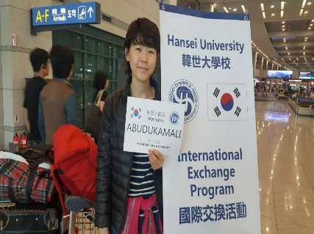
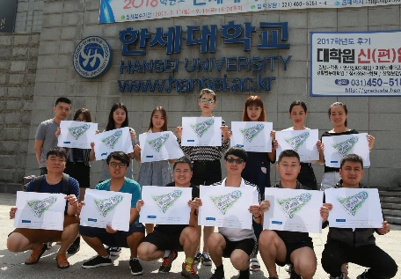

Orientation for Exchange Students Joint the Extra Curriculum Program
为交换学生的说明会 参加非课程活动
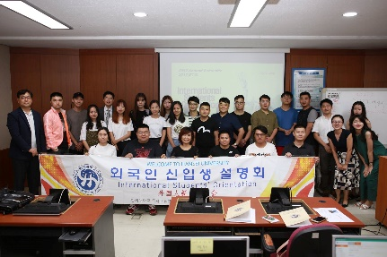
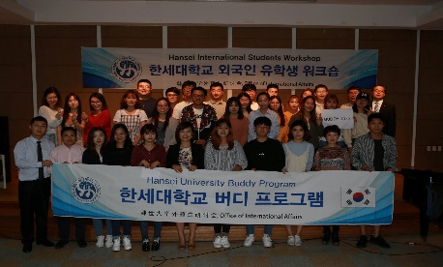

Study Korean language course Korean culture experience
韩语学习课程 韩国文化体验
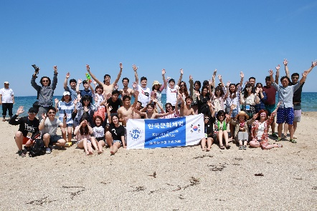
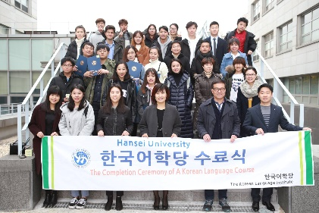

Participation in foreigner job fair Farewell party for Exchange Students
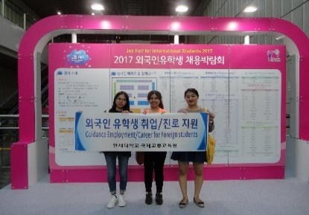
参加外国人就业博览会 交换学生欢送宴会

★以上的活动由本校的状况会有些变动
Communication with OIA, Hansei Univ.

1. If you want to talk with us, Add ‘KakaoTalk’ Plus friends (OIA Hansei Univ.) as your friend.
1.如果想和我们聊天的话，添加我们的 KakaoTalk’Plus friends ID (OIA Hansei Univ.)
1) How to add by URL? http://pf.kakao.com/_DVfWd
1)怎么用 URL 添加? http://pf.kakao.com/_DVfWd
2) Search ID in the Kakao Talk (搜索): oiahanseiuniv
2)搜索ID：oiahanseiuniv

如果你想跟
“韩世大学国际交流教育院”沟通
请加入KakaoTalk Plus的朋友（OIA Hansei Univ）

2. FACEBOOK: https://www.facebook.com/hansei.OIA
3. QQ: 2663492966Office of Inter
Office of International Affairs (OIA) Hansei University
韓世大學 國際交流教育院
Main  E-mail Address | 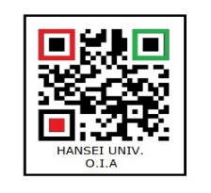  iec.hansei@gmail.com

